**Irving Elementary**

Start Time **7:50 AM**; Dismissal **3:00 PM**

500 West Clinton Avenue || 515.961.9560 || http://www.indianola.k12.ia.us



* Lunch Menu
* Irving Events
* Yearbook
* Box Tops
* District/Community Events
* Building Notes
* New Bus Pass Procedure

**Highlights**

Please call or email your student’s absence as soon as possible. If emailing, send your email to **both the teacher and me** since the teacher may be gone. Include your student’s reason for an absence when calling or emailing the office. It’s more important than ever that we know the symptoms your student is experiencing so our nurse can monitor illnesses.

I also need the absence reason so I can correctly enter an attendance code. --Thank You!

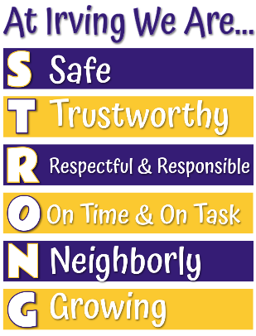

Irving Strong Trustworthy

During the month of September and October, Irving will focus on what it means to be trustworthy. We have a variety of classroom and school-wide safety activities scheduled.

Indianola Schools offers lunch and breakfast each day. Menus are available here: [Irving Menu](https://indianola.nutrislice.com/menu/irving-elementary).

The following options are offered daily:

* Breakfast: Assorted Fruit Juice, Cereals and Mozzarella Stick
* Lunch: Yogurt, Cheese Stick, Goldfish and Granola

|  |  |  |  |  |
| --- | --- | --- | --- | --- |
| **Intersession—Week 1**  **(for students attending full-day intersession)** | | | | |
| **Monday**  **September 20** | **Tuesday**  **September 21** | **Wednesday**  **September 22** | **Thursday**  **September 23** | **Friday**  **September 24** |
| ***Lunch option WILL NOT be offered during intersession.***  *** Menus are subject to change without notice. *** | | | | |
| **Breakfast** | **Breakfast** | **Breakfast** | **Breakfast** | **Breakfast** |
| Pancake on a Stick  Pears | Pop Tart  Cherry Craisins | Chocolate Breakfast Bread  Mixed Fruit | Lil’ John Donut  Raisins | Chocolate Chip Mini French Toast  Peaches |
| **Lunch** | **Lunch** | **Lunch** | **Lunch** | **Lunch** |
| Chicken Fries  Petite Roll  Corn  Applesauce  Cauliflower | Mini Corn Dogs  Tater Tots  Peaches  Romaine Lettuce | Mandarin Orange Chicken  Brown Rice  Steamed Broccoli  Frozen Mixed Berries  Tomatoes | Blueberry Bash Mini Waffles  Scrambled Eggs  Hash Browns  Pears  Fresh Carrots | Build Your Own Pizza  Hummus  Apple  Celery  Chocolate Chip Cookies |

|  |  |  |  |  |
| --- | --- | --- | --- | --- |
| **Intersession—Week 2**  **(for students attending full-day intersession)** | | | | |
| **Monday**  **September 27** | **Tuesday**  **September 28** | **Wednesday**  **September 29** | **Thursday**  **September 30** | **Friday**  **October 1** |
| ***Lunch option WILL NOT be offered during intersession.***  *** Menus are subject to change without notice. *** | | | | |
| **Breakfast** | **Breakfast** | **Breakfast** | **Breakfast** | **Breakfast** |
| Breakfast Pizza  Pears | Pop Tart  Cherry Craisins | Chocolate Muffin  Mixed Fruit | Cinnamon Roll  Raisins | Blueberry Bash Mini Waffle  Peaches |
| **Lunch** | **Lunch** | **Lunch** | **Lunch** | **Lunch** |
| Popcorn Chicken  Petite Roll  Corn  Fresh Carrots  Applesauce | Crispito  Cheddar Cheese Sauce  Lettuce  Salsa  Mixed Fruit | Pork Roast  Hamburger Bun  Baked Beans  Pears  Fresh Broccoli | French Toast Sticks  Tater Tots  Peaches  Cauliflower | Pepperoni Pizza  Green Beans  Strawberries  Celery |

1% white milk, chocolate milk and water are always offered with lunches.

If you need assistance, the free and reduced meal application is available here: [Free-and-Reduced-Meal-Application-Information](https://www.indianola.k12.ia.us/departments/food-service/fee-and-reduced-meal-application-information-test/). Indianola Schools is an equal opportunity provider. || *** Menus are subject to change without notice. ***



The USDA recently extended the Summer Food Program guidelines for emergency COVID meals for all school-aged children. Breakfast and lunch meals will be FREE TO ALL students **until funds run out**.



Not receiving text messages from the Indianola Community School District? You can opt-in by texting YES to 87569. (Standard message and data rates apply.) **If you still aren't receiving ICSD text messages, please contact your building secretary to confirm we have the correct contact information on file.**



Irving Events

**Every Wednesday Early Dismissal (2:00 for bus riders/2:05 for pick up/ walkers.)**

September 17 **No School**

September 20-October 1 Fall Intersession

October 4-8 Fall Break

October 11 PD Day for Teachers—**No School for Students**

October 18 Irving PTO meeting, 7:00 PM (in-person at Irving library and on Zoom)

November 1 Irving PTO meeting, 7:00 PM (in-person at Irving library and on Zoom)

November 23 Irving Music Programs

November 24 1 Hour Early Dismissal (2:00 bus riders/2:05 everyone else)

November 25-26 **No School**

December 6 Irving PTO meeting, 7:00 PM (in-person at Irving library and on Zoom)

December 17 **REVISED** 90-Minute Early Dismissal (1:30 PM)

December 20-January 9 Holiday and Winter Break

January 14 Building Meeting/Work Day—**No school for students**.

January 17 Professional Development Day—**No school for students**.

**Irving Music Programs**

**November 23**



Irving’s music programs will be on Tuesday, November 23, in the high school auditorium.

* The 1st and 2nd graders will perform from 6:00-6:30 PM.
* The3rd and 4th graders will perform from 7:00-7:30 PM.

**2021-22 Irving Yearbook**



**We need your help to make the 2021-2022 Irving yearbook great!**

Please email any school-related pictures to [irvingelementaryyearbook@gmail.com](mailto:irvingelementaryyearbook@gmail.com).

**Box Tops**



District/Community Events



You can search/subscribe to upcoming events in the district’s

Digital Backpack:

[www.indianola.k12.ia.us/digital-backpack](http://www.indianola.k12.ia.us/digital-backpack)

**Thursday Night Live**

**Volleyball Practices**

These practices are open to girls in grades 3-8 in the North gym at Indianola High School.

Thursday, Sept 9 6:15 to 7:30 pm

Thursday, Sept 16 6:15 to 7:30 pm

Thursday, Sept 23 6:15 to 7:30 pm

Thursday, Sept 30 6:15 to 7:30 pm

Thursday, Oct. 7 6:15 to 7:30 pm

No pre-registration is required.

For Questions please contact Kent Halstead [kent.halstead@indianola.k12.ia.us](mailto:kent.halstead@indianola.k12.ia.us)

**Building Notes**

|  |  |
| --- | --- |
| ***The bell rings at 7:50 AM.*** Your child will be counted tardy starting at **7:51** either as **excused:** | |
| * illness, * family emergencies, * recognized religious observances, * to accompany parents out of town, to attend funerals, etc.; | * appointments that cannot be scheduled outside the school day, * school-sponsored or approved activities; |
| **or unexcused with no note from the parent or for simply being late**. Unexcused absences also include, but are not limited to: | |
| * shopping, * hunting, * concerts, | * preparation/participation in parties/ celebrations, * and employment. |
| Truancy will not be tolerated by the board. .... **Ref.: School Board Policies 501.3, 501.9, 501.10**  ***You are now able to view absences and tardies by accessing your PowerSchool portal account.***  As a courtesy, please call or email any changes to your child’s pick-up arrangements for that day by **12:30 PM** unless you have an emergency. | |

**Exiting the Building:**

* **Kindergarten, 2nd and 4th grades** will enter/exit through the **southwest doors**.
* **1st, 3rd and 5th grades** will enter/exit through the **north door**.

Families with children in multiple grade levels may decide on one designated pick-up area. Please notify the classroom teachers of your decision.



Our Lost and Found rack is now in the hallway across from the gym for parents to check out.

Please put your child’s name on the labels of coats, sweatshirts, lunch boxes, etc., so we can return the lost items—even if you only put the first name.

* **x**

**Guidelines for Indoor Recess:**

If the temperature and/or feels-like temperature is 10° or below or 100° and above, students stay inside for recess.

Students will also come into the building starting at 7:30 in the morning.

**Recess and Lunch Time Reminders:**

**AM Recess**

K 9:25-9:40

1st/2nd 9:50-10:05

**PM Recess**

3rd/4th 2:00-2:15

1st/2nd 2:25-2:40

Cell Phones/Electronic Communication Devices

Students may possess a cellular telephone or other electronic communication devices (ECD) in school and at school related functions provided that **during school hours** and **on school vehicles** the **cell phone or ECD is powered off, concealed and not in use**.

*Students are prohibited from using a cell phone or having it powered on during the school day.*

K 2:40-2:55

**Recess**

**Time**

**Lunch**

K 10:50-11:10 11:10-11:35

1st 11:05-11:25 11:25-11:50

2nd 11:20-11:40 11:40-12:05

3rd 11:35-11:55 11:55-12:20

4th 11:50-12:10 12:10-12:35

5th 12:05-12:25 12:25-12:55

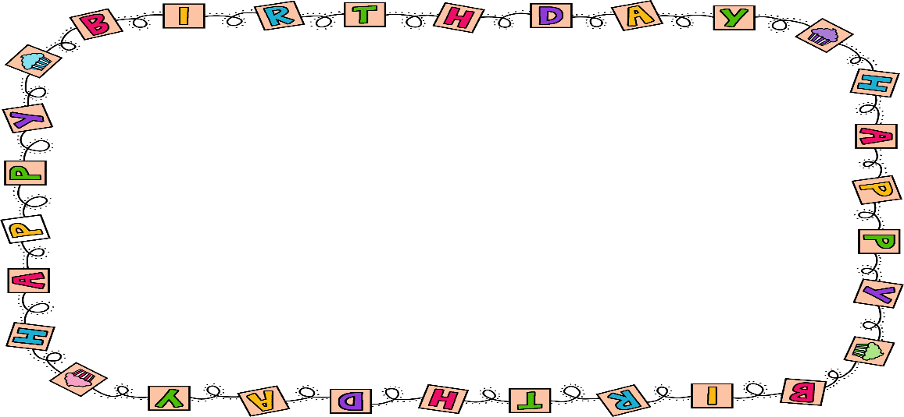

**Student Directory Information for Birthday Party Invites and Party Invitation Distribution**

Due to the Family Educational Rights and Privacy Act (FERPA), we are unable to give student identifiable information to outside individuals or organizations per our School Board approved handbook. Our school directory information is for school officials with legitimate educational interests. **Thus, teachers are unable to supply parents with the addresses of their peers for party invitations.**

**Notes from the Transportation Department:**

All bus students are expected to wear their seat belt during their bus route. If you child is having trouble with the seat belt, please ask the bus driver for help.

The middle school is a transfer point **only** for before and after school. Parents should be dropping off and picking up their children at their attendance center if they have plans other than their typical bussing needs.

According to the Student Transportation Handbook (found on the Indianola website): *‘. . . Elementary parents* ***cannot pick up or drop off elementary students at the Middle School*** *for transportation.’*

***\*\*\*NEW\*\*\****: Starting this school year, bus passes will now be approved by the Transportation Department and not your student's school office. The request will need to be submitted ***no fewer than 3 business days*** before the day of the trip to allow for proper planning. Passes normally will be approved as long as there is room on the bus and the request is submitted on time. To contact Transportation, please call 515-961-9592 or e-mail [ryan.whitesitt@indianola.k12.ia.us](mailto:ryan.whitesitt@indianola.k12.ia.us).

**Student Drop-Off/Pick-Up Information**

Dear Families:



[This Photo](https://www.aliem.com/category/non-clinical/expert-peer-review-nonclinical/) by Unknown Author is licensed under [CC BY-NC-ND](https://creativecommons.org/licenses/by-nc-nd/3.0/)

Our student drop-off/pick-up procedures are designed to maintain a safe and orderly arrival and dismissal for you, our students, and our staff. The following guidelines provide a general awareness to all involved as well as provide information that will help expedite the process.

Safety Rules

* Vehicles **MAY NOT BE LEFT UNATTENDED** in the “car rider lane” on Clinton Street from 7:30-8:20 AM and 2:40-3:25 PM. If you must leave your vehicle, please use an official parking space.
* Listen to school personnel for directions.
* Always be on the lookout for others.
* There will be one lane for pick-up/drop-off on Clinton Avenue. No double and triple parking.
* Students will not be allowed to go in-between cars to get to their own vehicle for drop off/pick-up.
* Students will not be allowed to load and unload in the intersection of Clinton and D Street or Detroit and D Street.
* Parents should not park behind the parked cars along the fence to the playground or on D Street to load or unload their student(s).

Student Arrival Directions

* Parents will not be able to enter the building at this time.
* All students must be supervised. **Irving Elementary will provide supervision beginning at 7:30 AM**.
* On Clinton Street, please pull all the way to the west end of the car rider lane and unload close to the ramp.
* Please have your student prepared to exit the vehicle at the appropriate time to keep traffic flowing.
* Students may not be dropped off from the street on Detroit or D Street. Please utilize the Simpson parking lots on the north side of Irving and have the students cross at the crosswalk.
* **Students MUST be IN CLASS at 7:50 AM. They are tardy at 7:51 AM**.

Student Dismissal Directions

* Dismissal for bus begins at 3:00. **Only bus students may be dismissed at this time.**
* If you need to pick your child up early, **you will need to park in an official parking place, come into the main office and sign your child out**.
* Dismissal for car riders and walkers begins at 3:05.
* Dismissal areas-
  + North Door—1st, 3rd and 5th grades
  + Southwest Door—Kindergarten, 2nd and 4th grades
    - Families with children in multiple grade levels may decide on one designated pick-up area. Please notify the classroom teachers of your decision.
* Please pull all the way up to the ramp area to allow us to load the maximum number of cars at one time. (All students will come from the ramp area on the west end of the building.)
* With proper flow, approximately 4-5 cars can pick up at one time, leave and then allow 4-5 more cars to pick up near the ramp.
* Teachers will be there to assist students to get to their car. PLEASE DO NOT LEAVE YOUR CAR UNATTENDED IN THE PICK-UP LANE.

Other Available Options

* There are two Simpson parking lots to the north of the building where you can plan to meet your child after school.
* Parking is also available on one of the side streets in the area. You may park and walk to meet your child at school.
* If your child qualifies for transportation services, they may utilize the District’s busing.
* The Simpson parking lot on the south side of Clinton **IS NOT** available for parents to utilize before and after school for parking.

We ask for your focus and patience as all parents and students learn the new procedures. Please remember that traffic is always heavier at the start of the school year, so plan your time accordingly. The Indianola Police Department will be prominent during the first week and a half of school to help maintain procedures and traffic flow.

Derek Morris, Principal

NOTICE OF NONDISCRIMINATION

It is the policy of the IndianolaCommunity School District not to discriminate on the basis of race, color, national origin, sex, disability, religion, creed, age (for employment), marital status (for programs), sexual orientation, gender identity and socioeconomic status (for programs) in its educational programs and its employment practices. There is a grievance procedure for processing complaints of discrimination. If you have questions or a grievance related to this policy please contact Special Programs Coordinator, 1301 East 2nd Avenue, Indianola, Iowa 50125, 515-961-9500. spcoordinator@indianola.k12.ia.us.

**Code No. 102.E3**

It is the policy of the IndianolaCommunity School District not to discriminate on the basis of race, color, national origin, sex, disability, religion, creed, age (for employment), marital status (for programs), sexual orientation, gender identity and socioeconomic status (for programs) in its educational programs and its employment practices. There is a grievance procedure for processing complaints of discrimination. If you have questions or a grievance related to this policy please contact Director of Human Resources, 1301 East 2nd Avenue, Indianola, Iowa 50125, 515-961-9500, hrdirector@indianola.k12.ia.us.

**Code No. 102.E2**

|  |  |
| --- | --- |
| 504 Coordinator | Title IX |
| Special Programs Coordinator Sarah Baker | HR Director Mimi Kelly-Meyer |
| 1301 East 2nd Avenue | 1301 East 2nd Avenue |
| Indianola, IA 50125 | Indianola, IA 50125 |
| (515)961-9500; Ext. 3114 | (515)961-9500; Ext. 1502 |

who has been designated by the school district to coordinate the school district’s efforts to comply with the regulations implementing Title VI, Title VII, Title IX, the ADA, § 504 and Iowa Code 280.3 (2007).